JPMC Placement Experience
Batch(2019-2023)
Name : Pratik Vartak
Job Offered : Yes & Accepted
CGPI : 9.43
Criteria : 7CGPA+
Email : pratikvartak229@gmail.com
Contact Number : 9324949289
Linkedin : https://www.linkedin.com/in/pratik-vartak-269502203/
TimeLine:
JPMC RoadShow (Pre-placement Online
4, 7 and 8 March 2022
event - Zoom)
Approximately 4-5 day window was given for attempting Coding Round and Interviews since the emails were sent out in batches.
Coding Round (Hackerrank) 18-20 March 2022
Interview Round (HireVue) 26 March - 1 April 2022
Shortlist Result 09 May 2022
CodeForGood Bootcamps (GitHub,
24-26 May 2022 (1 hr sessions every
Office Hours, Presentation Skills) - Zoom
day)
Slack Invites 25 May 2022
BeMyApp Registration Invites 08 June 2022
JPMC CodeForGood Hackathon 11 - 12 June 2022
Final Shortlist Result 19 July 2022

About Rounds :
Round 1:
It was basically a cakewalk round with two coding questions at an easy level if you have done a enough leetcode grind.
Q1:Convert decimal to binary and then reverse the binary string thus obtained and then print the decimal for the reversed string .(based on simple bit manipulation technique)
Q2:https://www.geeksforgeeks.org/minimum-number-of-distinct-elements-after-rem oving-m-items/
(simple greedy strategy using hashmap)
Important Guidelines:
● Your camera has to be switched on at all times during the test.
● Hackerrank has strict plagiarism detection software that makes use of M.O.S.S which
can easily identify whether your code is original or not.
Round 2:
Link for attempting round 2 was soon mailed to us with instructions to attempt Platform of interview was Hirevue. If you do some background research about the platform it uses AI so things like your confidence, expressions, voice, lightings play a very major part.
Questions : Questions were almost the same for everyone.
1. Tell us about an experience you have had, that you would describe as a learning experience. Tell us about the problem and the outcome.
2. Tell us about the specific career goals that you have set for yourself.
Note : There were 2 attempts for each question. Time limit for each question was 1 min 30 secs
Practice a lot on hirevue and other virtual interview platforms since it is AI based of course it focuses on following aspects
● Facial expressions (be with a positive attitude a smile throughout (not a weird one XD)
● KEYWORDS (What i did was explored JPMC careers page saw what techs they used ,leadership qualities they nurture and included them in my ans ) . ● TO THE POINT (Only speak what is asked) .
● BE CONFIDENT
Round 3: Code For Good(CFG)
Because of COVID this round was totally online,this round was a 24 hour hackathon in which 5 NGOs came with their problem statement and we had to give our preferences of the problem statement provided to us and based on that one final statement was given to us.
Timeline
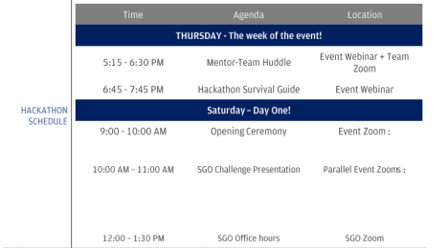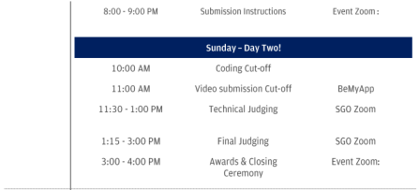
● SGO Assigned - Center for Gender and Politics
● Team No. 85
● Team Size - 8 (later reduced to 5, since people dropped out) ● No. of Mentors -3
➔ On 9th of june our team mates were released and immediately we found ourselves via linkedin and slack.we made our unofficial whatsapp group where there were no mentors present and then before mentor hurdle we connected on gmeet to get to know ourselves and with what technologies we are familiar with.we choose REACT (FRONTEND) ,FIREBASE (BACKEND) and PYTHON STACK as backup Tech Stack and those who were not knowing these technology ,we gave them material to prepare before hackathon.
UNDERSTAND PROBLEM STATEMENT:
➔ Be clear with the problem statement
➔ Clear your doubt then and there itself so that you can start brainstorming asap. ➔ Discuss ways to solve it along with opinions of mentors ,don't hesitate,they are there to help.
TECHNICAL TIPS :
➔ Be ready with code templates of certain reusable components such as login,signup,backend server structure ,request response skeletons ,authentications.
➔ Be familiar with what are you incorporating and why are you using a particular concept/code script not in depth but superficial knowledge would be great.
➔ Be on the same page make sure your teammates have a clear idea of how the project will proceed,what is expected and what is used for what .
➔ Play to win i.e try to complete what are you gonna build ,and dont hesitate to COPY PASTE.
➔ If you are stuck somewhere or facing errors and bugs don't waste time and immediately call SMEs and resolve errors
➔ Learn a few popular tech stacks like MERN can come in handy since that’s what a lot of teams end up using. I’d recommend learning React, and Django and working with Databases like MySQL and MongoDB.
PRO TIP : DON'T SLEEP
OTHER TIPS :
➔ Take breaks no issues ,but be sure you are always on earphones as mentors can call you any time ,or inform teammates before leaving so there's no miscommunication .
➔ Be interactive throughout, present your opinions ,include your dormant teammates into the discussions,don't try to be a leader or compete among teammates but if no one is taking the initiative then be the first to do so.
➔ Keep mentors in the discussion and make it lively .
➔ Try to contribute as much as possible and make worthy contributions .
➔ Assign your teammates tasks,if a teammate needs help take some time and do it ,it all counts mentors observe you majority of the time .
Rest everything is chill and no need to worry if you have reached till CODE FOR GOOD You are 90% closer to selection ,just follow above tips and you are good to go .
Note: Winning or being a finalist is neither necessary nor a guarantee that you will be given an offer by JPMC. So, do not get disheartened, if you cannot get to the finals.Also There is also a chance of you not getting an offer,so start preparing for the aptitude test of other companies.
All The Best :)

